

Program: ESE 4009

INSTRUCTOR: Prof. Mike Aleshams

Group 9

STUDENT NAME | STUDENT ID | SIGNATURE
SADGUNA RAO | C0744095 | SR
SUPREET | C0744184 | SB
RASANDEEP | C0727753 | RS

*By signing above, you attest that you have contributed to this submission and confirm that all work you have contributed to this submission is your own work. Any suspicion of copying or plagiarism in this work will result in an investigation of Academic Misconduct and may result in a “0” on the work, an “F” in the course, or possibly more severe penalties.
Project Proposal
Final draft

Project Title:
IOT BASED ACCURATE THERMAL SCREENING AND ALERT FOR COVID SITUATION USING BEAGLEBONE

Description of the latest similar system:

Contactless temperature sensing via luminescence
(IEEE PROJECT)
Sensitive detection of temperature in a non-contact fashion has applications in many diverse areas and disciplines. Immediate need exists for non-contact temperature measurement of moving or contact sensitive objects, hardly accessible bodies, or objects in hazardous locations. Materials and sensor platforms used for non-contact temperature measurements often limits their use in certain environments.
The changes of luminescence properties of materials with temperature (such as changes of absolute and relative emission intensities, lifetime values of excited states, emission rise times, peak positions, and emission bandwidths) allow some materials to act as sensitive thermometers. The phenomenon become the basis of a new arm in the field of luminescence spectroscopy commonly termed as a luminescence thermometry. This lecture presents an overview of different modalities of luminescence thermometry, such as the use of materials with a single- or multi- emission centres, the selection of the reference emission, and advantages or disadvantages of the emission intensity measurements versus measurements of temporal changes in emission.
Then, different classes of materials commonly utilized for luminescence thermometry are listed along with their figures of merit (temperature sensitivities, resolutions, measurement ranges. These include rare earth doped optical fibres, phosphors in forms of powders, thin films and ceramics, organic-inorganic hybrids etc. Finally, several state-of-the-art applications of remote temperature sensing with luminescence are shown.

Limitations of the latest similar system:

- The project uses several under development technologies which are not accurate presently.

- The project doesn’t consider distance as a factor which can affect the values a lot.

- The accuracy of the system is not verified.

Final Solution:
Block Diagram

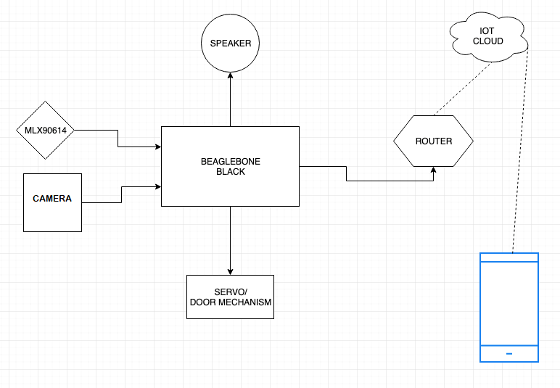

- Features
- Notification alert if abnormal temperature detected

- Can be integrated with door, hence doors will only open if person is safe to go.

- Automated Contactless Temperature measurement.

- High accuracy achieved.

- Use of various peripherals such as touch screens, cameras, microphones and speakers, GPIOs, timers, GPS modules, Bluetooth, WiFi, and ADC/DACs?

  - A Camera is used to monitor and record the data.
  - Temperature Sensor is used to measure the body temperature of monitored people.
  - Servo motor is used to Open/Close the door.
  - Speaker is used for raising alert sound and feedback.
  - Wi-Fi module is used to connect to the internet.

- Use of I2C, SPI, RS232/RS-485, IrDA infrared, JTAG, USB, Bluetooth, IEEE 802.11 Wi-Fi, IEEE 802.3 Ethernet, CAN and GPS protocols and systems?

- Wi-Fi 802.11 is used for communication with IoT Server.
- I2C protocol is used to communicate with temperature sensor.

- Use of preemptive versus cooperative scheduler operation; tick rate and time slicing; critical code; fixed, dynamic and hybrid task priority allocation; application-specific considerations; power management tactics; semaphores, mutexes and queues; debugging strategies; performance estimation?

  - There is no priority task usage in this project, so we are not implementing any functions like schedulers or mutexes.

- Hardware and Software Requirement
  - Hardware:
    - Beagle bone Black
    - MLX90614 Temperature Sensor
    - Speaker
    - Servo Motor
    - Li-ion Batteries
    - Camera
    - Router
    - Wires
  - Software:
    - Linux OS.
    - EasyEDA
    - Eclipse IDE
    - AWS

- Milestones
SADGUNA RAO | SUPREET | RASANDEEP | Deadline
Buying the components | Testing the components | Drawing the schematics | Jun-26
Interface the Temperature Sensor | Testing the components | Drawing the schematics | Jul-03
Interface the Temperature Sensor | Interfacing speaker to Beaglebone. | Drawing the schematics | Jul-10
Interface the Temperature Sensor | Interfacing speaker to Beaglebone. | Interface the servo motor | Jul-17
Interface Camera to Beaglebone | Interfacing speaker to Beaglebone. | Interface the servo motor | Jul-24
Interface Camera to Beaglebone | Interfacing router to the Beaglebone | Interface the servo motor | Jul-31
Interface Camera to Beaglebone | Interfacing router to the Beaglebone | Setting up the cloud service | Aug-07
Finalizing the project | Interfacing router to the Beaglebone | Setting up the cloud service | Aug-14
Finalizing the project | Finalizing the project | Setting up the cloud service | Aug-21

- References:
  - Components101. (2020, March 31). MLX90614 Non-Contact IR Temperature Sensor Pinout, Datasheet, Equivalents & Specs. https://components101.com/sensors/melexis-mlx90614-contact-less-ir-temperature-sensor
  - BeagleBoard.org. (2019, September 6). BeagleBoard.org - black. Retrieved June 5, 2020, from https://beagleboard.org/black
  - M. D. Dramićanin, Z. Antić, S. Kuzman and T. Thundat, "Contactless temperature sensing via luminescence," 2016 18th International Conference on Transparent Optical Networks (ICTON), Trento, 2016, pp. 1-1, doi: 10.1109/ICTON.2016.7550592. https://ieeexplore.ieee.o

- Instructor’s remarks:

